ECE 3300L

Lab 6

Instructor: Dr. Mohamed El-Hadedy

Group A

Sami Elias 012546378 [samielias@cpp.edu](mailto:samielias@cpp.edu)

Joseph Popoviciu 014357772 jdpopoviciu@cpp.edu

**Objective:**

Modify Lab 5 to use 4 switches to load a value into a specific digit of the seven-segment display based on the input switches to a 3x8 decoder.

**Results:**

Schematic

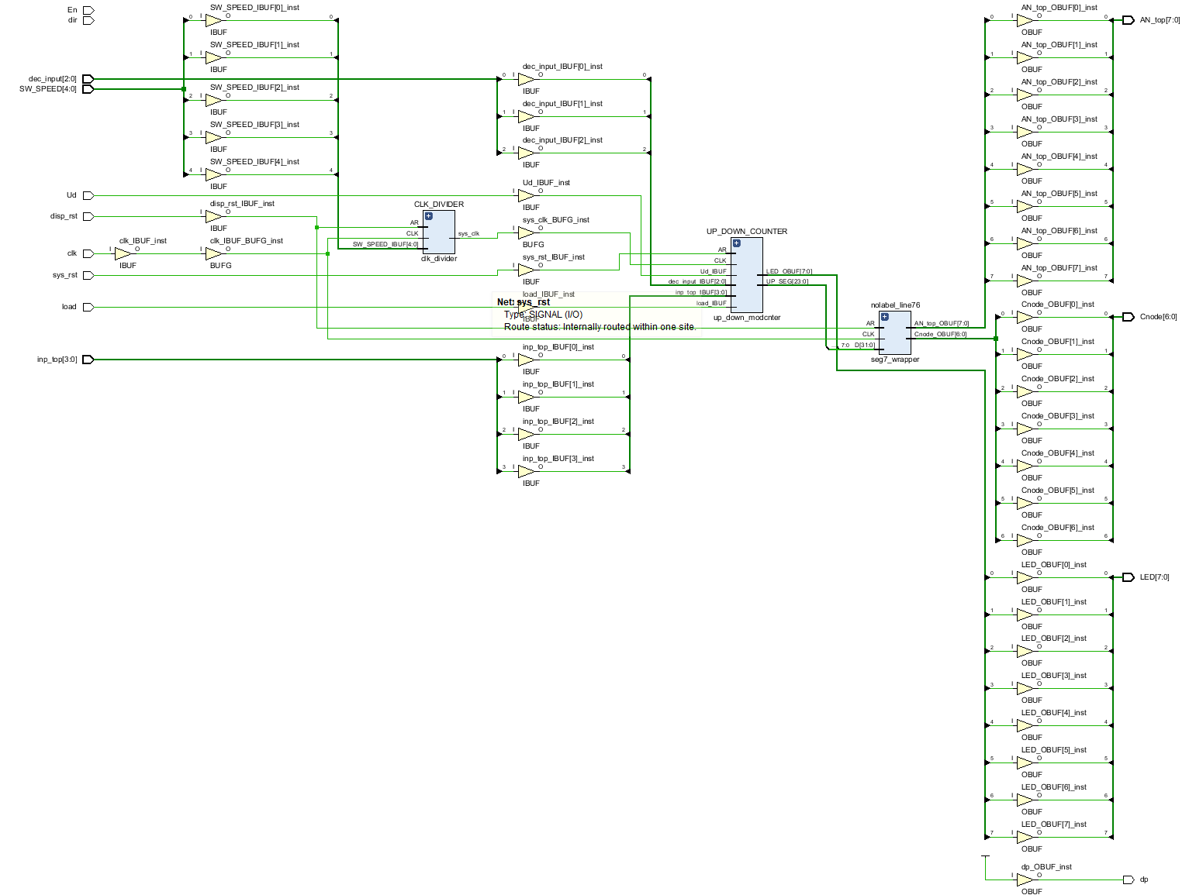

**Utilization:**

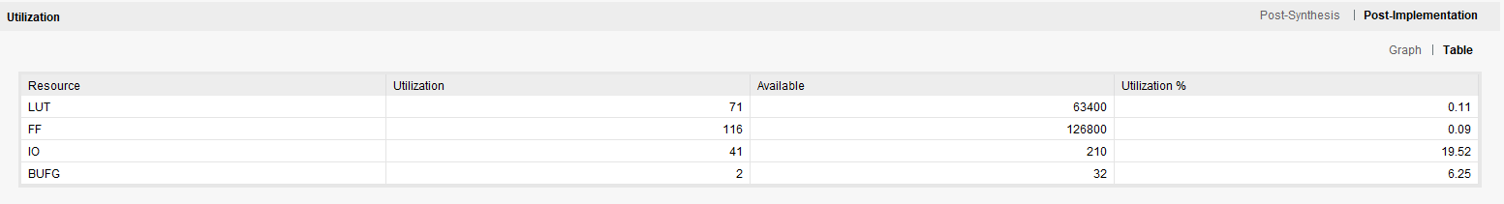

**Power:**

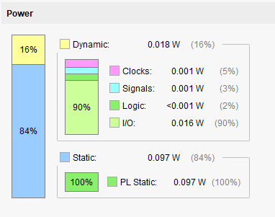

**Conclusion:**

We created an up/down counter that allows us to load in a value and count up or down from the loaded value. When we load in the value, we press the load button to load that value into the counter and let the counter resume counting either up or down. Based on the inputs to the decoder the count will switch to a different display. If we switch it to count down, it will start counting from the value it was left at. If we hit the reset button, it goes back to zero. If we hit the load button while it is still counting, it will go back to whatever the value we had it load.